AN ADVANCED H2O CONTAINER GOVERNANCE USING IOT

Dr. R. SRIDEVI SAISRI B, SANTHOSH KUMAR P, UMA MAGESWARI KK

Associate Professor Master of Computer Application

Department of Computer Science Department of Computer Science

CHRIST (Deemed to be University) Bangalore CHRIST (Deemed to be University) Bangalore

[sridevi.r@christuniversity.in](mailto:sridevi.r@christuniversity.in) [santhosh.kumar@mca.christuniversity.in](mailto:santhosh.kumar@mca.christuniversity.in)

***Abstract*** — This project automates water management using IoT and a mobile app. It ensures tank fill-up and motor control based on water levels sensed by ultrasonic sensors. Security features include PIN and fingerprint authentication. Turbidity, salt, and water flow levels are monitored along with leak detection. The system predicts water consumption, suggests refill requirements, and integrates with multiple tanks. A camera provides live monitoring. Alerts are sent for low water flow or tank cleanliness issues. The mobile app offers automatic and manual modes, including voice assistance. Solar power backup ensures continuous operation. In case of power failure, the system switches to solar or battery power. Automatic cleaning and notification features maintain water quality. Family members receive alerts and updates.

Keywords:— Raspberry pi, ultrasonic sensor, TDS meter, turbidity sensor, flow rate sensor, camera, RFID, LED lights & display, Fingerprint sensor, Number pad GSM, buzzer, solar panel.Top of Form

1. INTRODUCTION

To Live, all the organisms need five elements of nature (Water, Land, Air, Sky, Earth), Water is one of the five elements of nature, without water no organism can survive. Getting water from sky as rain storing the water, making use it in several ways like washing, bathing, cooking, drinking, to generate some kinds of energy like (Electrical Energy), agriculture and irrigation, emergency purposes (Fire accidents), Industrial purposes, hydro-vehicles, etc. Water is most important for Aquatic animals to live. Most importantly water is used for balancing the environment (ecosystem and biodiversity), To get water unlimitedly, we have to utilize it properly, irrigating to plants and trees then we will get a good rainfall through water cycle. If there is no proper water cycle, then no climatic changes happen, then the earth started destroying slowly (Environmental Degradation) also causes global warming.

On every year March 22nd is celebrated as World Water Day. I’m reminding a poem of An Indian Tamil poet THIRUVALLUVAR who articulates in 2000 years back in Tamil classic THIRUKKURAL he says “Without water today you will not be for anyone in the world without sky discipline will not exist today”. Which means If the world cannot exist without water, neither can water exist without rain. Without rain there exists water and without water agriculture is not possible which will eventually lead to hunger in the world, automatically humans will start to steal from others, if nothing exists to steal from others, humans would start to eat other human then the world would slowly get into destruction phase, Water saves us but in today’s scenario we need to save water. In early stages water resource was available for free from nature but now we are getting water by paying money because of human made things.

We are busy with our daily works, sometimes we may forget to monitor the water level and fail to turn ON and OFF the motor. This project helps the senior citizen, disabled person, and busy people. In this project water will be automatically filled in the tank, using IoT (Internet of Things) and Mobile Application, cleanliness of water, information and reports of water system are generated as graphs can be viewed in Mobile application, Display and voice assistance for disabled person.

IoT refers to a network of computerized devices linked to the internet or another computer network. They can be remotely operated and exchange data with one another or a centralized network. They can also operate and continuously check their performance and conditions, In terms of sensors size and communication protocols. IoT devices can vary widely. The Internet of Things is supported by connectivity and device interoperability. This results in a network of seamlessly connected devices and the cloud. This makes data collecting, processing, and storage decentralized. Many different sectors can use IoT. It can be applied to manufacturing to enhance asset utilization and process management. IoT gadgets can maximize agricultural productivity, fertilizer use, and water use in agriculture. IoT can be used in healthcare to manage patient care, monitor devices, and collect data. The most important features of IoT on which it works are connectivity, analyzing, integrating, active engagement, and many more.

# MOTIVATION

# One of my friends is physically challenged (blind) he lives alone, every day he struggles to fill water in the water tank and to check the cleanliness of water. My house is behind one of my uncle’s house, he and his family fail to check the water level and water over flows from the tank most of the times, I inform them else I switch OFF the motor, sometimes they leave the house with motor switched ON. In my house I’m responsible for monitoring the water level in the water tank. I couldn’t predict the status of the water level in the tank, I go to terrace and monitor, it gets late to fill the tank and I get bored by monitoring the water level, so I come down, after some time again I go to terrace and monitor, repeatedly it happens, so it’s difficult to monitor the water level and sometimes I forget to check the voltage level before switching ON the motor, in this paper I had brought out some features which helps any kind of physically challenged people, senior citizens and busy people to fill water in the tank without any human error, information and reports of water system is generated and sent to the users mobile.

# RELATED WORK

In existing model Multiple sensors are used to measure the water level, the water motor is turned ON automatically when the water level is shown low and turned OFF when the water level is high [1]. It sends message “Water level is low, Turn ON the motor” to the user when the water level is low [2]. When water level is low and high it gives light indication in the display [3]. When water level is low, it automatically turns ON the motor and sends message to the user “Water level is low, motor turned ON” and turns OFF the motor when tank is about to fill and sends message to the user “Water level is high, motor turned OFF” [4]. Automation of water pump is done but before pumping the water motor it checks the voltage level [5]. It automatically switch ON and OFF the motor and it sends data to the cloud [6]. Automatically Pumps the water motor and checks the turbidity level [7]. Based on the water level it displays the level in the monitor and automates the water pump [8]. With the automation of water pump it checks the salinity [9]. It generates current status of water system report in Blynk App [10].

1. PROPOSED WORK

The main objective of the paper is to control the water wastage from the water tank, here the technology of IoT(Internet of Things) is used, using IoT we can monitor the water level in the water tank with the help of mobile application, ultrasonic sensor which senses the water level and the data stored in database which is reflected in the mobile application, the user need not to come to the terrace to check the water level every time, user can monitor the water level at any time at anywhere in the mobile application and also user can turn ON the motor if the water level is low and turn OFF if the water level is high using voice assistance and in the mobile application.

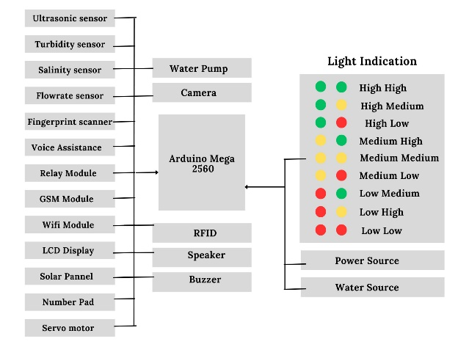

Fig 1 Block Diagram

# MODULES

"An Advanced H2O Container Governance using IoT" consists of seven main modules.

* Water Level Detection
* Control of Water Pump
* Water Quality
* Live Monitoring
* Switching to Other Tanks
* Exporting Data to Firebase and sharing information to user
* Report Generation

**Water Level Detection**

In this project the main component is ultrasonic sensor which senses the level of water in the water tank. if the water level is shown low motor will automatically turn ON, once the tank is nearly to fill the tank, automatically the motor will turn OFF. Turning ON and OFF the motor is automatically done using relay. There are nine water levels (High High, High Medium, High Low, Medium High, Medium Medium, Medium Low, Low High, Low Medium, Low Low). Motor will turn ON at water level “Low Low” and turn OFF at “High High”.

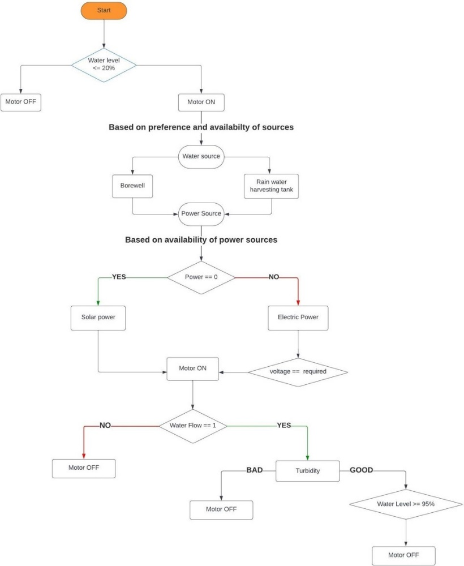

Fig 2 Data Flow Diagram

**Control of Water Pump**

We can also able to turn ON and OFF the motor by locally and in remote place. For local, authentication will be there because sometimes mistakenly we or kids or pets may turn ON or OFF the motor, authentication is done by using number pad by entering PIN number and fingerprint. If third person trying to switch ON the motor by authenticating, it alerts the user by an alert message. This project is integrated with mobile application. In Mobile application the user will have all the access to the water system. In Mobile Application there are two modes Automatic mode and Manual mode. In Automatic mode there is a default setting to all for the water system, In Manual mode we can set settings to all for the water system. If user wants to manually switch ON the motor or fill the water tank from any water levels, done from locally and remote place (mobile application). If an user is ordinary person able to turn ON and OFF the motor from locally and remote place with or without the help of voice assistance, A display in house there is a voice input reader, we can turn ON/OFF the motor by giving the command through voice. If an user is disabled person able to turn ON the motor in remote place using mobile application with the help of voice assistance. To function the water system getting Power source from solar (Reducing the consumption of electricity). If solar power is not or not enough much to pump the water motor, then it will choose power source from Electric board (Direct Current) Before turning ON the motor it checks the voltage whether it is enough to turn ON or not. Motor is running and the power source is from Electric Board, if the power is gone then automatically motor turned OFF, once the power comes it immediately checks the voltage and turn ON the motor else it takes power source from solar energy which we stored.

**Water Quality**

Level of Turbidity is measured using turbidity sensor. Level of Salt is measured using TDS meter. Water flow level is measured using water flow sensor. Leak detection is monitored using leak detection sensor, if the cleanliness of water is not good the alert message is sent to the user that the water is not good to use. The user is informed about it with an alert message to clean the water tank based on the dirty and salty present in the water tank.

**Live Monitoring**

Camera is fixed on the cap of the tank by inside. Camera is to monitor the water level, water flow level, or anything inside the tank (eg :- rat, lizard) by live through mobile application. Sometimes there is might be a situation where there is no water in borewell and rain water harvesting tank, if an empty motor keeps on running means, further the motor fail to function, sometimes fire accidents may happen. To avoid this type of problem we are using water flow sensor and camera to monitor the water flow. If the water flow level reduces the alert message is send to the user. If anything like rat, cockroach, lizard falls inside the tank or due to high level of salty and turbidity the water from the tank is automatically poured out or poured to plants, and information is sent to the user to clean the water tank, after updating the status that the tank is cleaned the motor will turned ON. Alert message and information are sent to all the family members in a house.

**Switching to Other Tanks**

We can also able to switch water to other water tanks. Multiple water tanks in a house if water level is low in any of the tanks, the gate valve will be automatically set to respective water tank It sends message to the user that the “nth” tank has low water level and gate valve set to “nth” water tank after that motor will turn ON and turn OFF once it is about to fill.

**Exporting data to Firebase and sharing Information to user**

If the water level is low and any information about the water system the message is passed to all the house members mobile phone as voice and text message and also displayed in the house display. All the data (salt content, turbidity level, water level, time, date, etc.) regarding water system is exported to firebase.

At house there is a common display on that Date, Time, water level in percentage, light indication, live video shown, water consumed, water flow level, salt level, turbidity level, no of times motor turned On, time taken to fill the tank & how much duration it takes to fully consume water, liters required to fill the tank and no of liters consumed, motor status (On / Off), motor turned On by whom (Man/Machine) Through (Local/Mobile App) And which mode (by hand/voice), leak detection, Power from which source (DC or Solar Power), water filling from which source (Borewell, Rain water harvesting tank), water consumed, liters filled, turbidity, salt, etc, all these things are compared with On this day in last year, month, week, between two days, yesterday and today, two weeks, two months, two years, two decade, n no of days, n no of weeks, n no of months, n no of years, particular date, time, period, season displayed in the display and also generated as a report.

**Report Generation**

How much time and liters it takes to fill the tank is also predicted. Calculating how many times motor turned ON in a day. Calculating how much water consumed in a day. Comparison of water consumption between two days, two weeks, two months, two years and two decades. Based on water that we consumed yesterday and today, how much amount of water will need for Tomorrow is predicted. No of liters required and consumed, at which time the water level will be Low (Time take to consume full water), time take to fill the tank, no of times motor will turn On, Available source, Water fill from which source are predicted for Tomorrow, all the details are generated as a report send to the user in mobile application and displayed in the display.

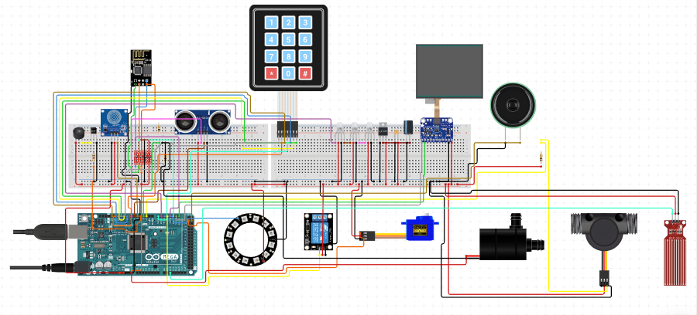

Fig 3 Circuit Diagram

1. CONCLUSION

Through this project we are trying to avoid water wastage (saving water), helping disabled persons and senior citizen to get benefit and it also helps in saving the time of busy people, taking care of health by checking salt and turbidity level, to be aware anything about water system generates prediction, by automating the water system it reduces human error and power.

1. REFERENCE

1. Smart water quality monitoring system with a cost-effective using IoT Sathish Pasika, Sai Teja Gandla Department of Electronics and Communication Engineering Chaitanya Bharathi Institute of Technology, Hyderabad (TS), India.

2. Internet of Things (IoT) based Smart Water Tank Level Monitoring and Motor Pump Control System for Prevent Water Waste Md. Tahmidul Huque, Jafreen , SM Raziur Rahman, Fabia Zaman, Ehtashamul, Sadah Anjum Shanto6 1,2,3,4,5BSc

Student, Dept. of Computer Science and Engineering, Bangladesh University of Business and Technology, Mirpur-2, Dhaka, Bangladesh 6Assistant Professor, Dept. of Computer Science and Engineering, Bangladesh University of Business and Technology, Mirpur-2, Dhaka, Bangladesh

3. Review IoT Based Smart Water Quality Monitoring: Recent Techniques, Trends and Challenges for Domestic Applications Farmanullah Jan , Nasro Min-Allah and Dilek Dü¸stegör (MDPI)

4. Noorjannah, S.; Asnawi, A.L.; Abdul Malik, N.; Mohd Azmin, N.F.; Jusoh, A.Z.; Mohd Isa, F.N. Web based water turbidity monitoring and automated filtration system: IoT application in water management. Int. J. Electr. Comput. Eng. 2018, 8, 2503–2511.

5. A Smart and Sustainable Home Aquaponics System with Feature-Rich Internet of Things Mobile Application by R Mahkeswaran University of Glasgow Singapore Singapore Andrew Keong Ng* Singapore Institute of Technology Singapore e-mail: Andrew.Ng@SingaporeTech.edu.sg, 2020 6th International Conference on Control, Automation and Robotics

6. An IoT-MOBILE ENABLED SMART WATER LEVEL CONTROLLING SYSTEM TO REGULATE WATER WASTAGE Siddartha Shankar , Dr M Dakshayini Student B.E. ISE, Professor, Dept. of ISE BMS College of Engineering, Bangalore, India 1 sidd112008@gmail.com 2 dakshayini.ise@bmsce.ac.in

7. An Internet of Things based Smart Water Tank with Android application Priyen P. Shah , Anjali A. Patil , Subodh S. Ingleshwar. An International conference on I-SMAC (IoT in Social, Mobile, Analytics and Cloud).

8. 2021 2nd International Conference on Intelligent Engineering and Management (ICIEM) IOT based Smart Water Pump Switch Peddamallu Jaya Prakash Reddy School Of Computer Science and Engineering Lovely Professional University Phagwara, India jayaprakashreddyp2000@gmail.com Guntimadugu Viswanadh School Of Computer Science and Engineering Lovely Professional University Phagwara, India visvanathraju2135@gmail.com Sanjay Kumar Singh School Of Computer Science and Engineering Lovely Professional University Phagwara, India sanjayksingh.012@gmail.com

9. A Smart Water Management Using IOT Sayali Wadekar Department of Electronics & Telecommunication Engineering Terna Engineering College, Navi Mumbai wadekar.sayali@yahoo.com Vinayak Vakare Department of Electronics & Telecommunication Engineering Terna College of Engineering, Navi Mumbai vinayak.vakare8@gmail.com Ramratan Prajapati Department of Electronics & Telecommunication Engineering, Navi Mumbai Shivam Yadav Department of Electronics & Telecommunication Engineering Terna Engineering College, Navi Mumbai Vijaypal Yadav Department of Electronics & Telecommunication Engineering Terna Engineering College, Navi Mumbai.

10. An Automatic Control Based on Voice Commands and Arduino by Alfiantin Noor Azhiimah, Meini, Agus Budi Santosa.

11. Smart water tank monitoring system using NODEMCU with android application by Poornachandran S, Ravinath D, Santhosh P, Tamilselvan D, Srinevasan M

12. An IOT Design Monitoring Water Tank Study Case : Instituto Profissional De Canossa (IPDC) by João Elias Da Costa Magister Informatika Universitas Atma Jaya Yogyakarta Yogyakarta, Indonesia.

13. A Real time Implementation of Home appliance control using ALEXA by S Somesh , N Senthilnathan, M Sabarimuthu, A Santhosh Kumar, R Rishikeshanan, V Bala

14. Design and Development of IOT Based SMART water distribution network for Residential areas Chetan S. Patel Dept.of Instrumentation & Control Engg. chetan.patel18@vit.edu Jitendra A. Gaikwad Dept. of Instrumentation & Control Engg. Vishwakarma Institute of Technology, Pune, India. jitendra.gaikwad@vit.edu Proceedings of the Fourth International Conference on Communication and Electronics Systems (ICCES 2019) IEEE Conference Record # 45898; IEEE Xplore ISBN: 978-1-7281-1261-9

15. A Smart IOT BASED WATER LEVEL MONITORING AND IMPLEMENTATION ON BOTH AGRICULTURE AND DOMESTIC USE AREAS Jisha RC, Vignesh G, Deekshit D Department of Computer Science and Applications Amrita Vishwa Vidyapeetham, Amritapuri, India 019 2nd International Conference on Intelligent Computing, Instrumentation and Control Technologies (ICICICT)